**Music supplement to the Lutezine to Lute News 140 (December 2021): Deutche Dantz Die schöne Somer zeytt (Hudson 12) - The Healths & All the Branles in french lute prints**

**Die schöne Somer zeytt - Almande d'Amour**

Here is the last in the series of the fifteen most popular Deutsche Dantz listed in Richard Hudson *The Allemande, The Balletto, and the Tanz:* I *The History;* II *The Music* (Cambridge University Press 1986), p. 35. All twenty four versions for lute and cittern that I know (H12a-x) are edited here some with barring and rhythm signs reconstructed, the edotorial changes usually indicated in grey in the tablature. The sources are equally divided between German and French tablature (see p. iv below for facsimile pages of H12a & H12i), and six more are for keyboard or instrumental ensemble.[1] Few bear the German title *Die schöne/ schena/ fröhlich Somer zeytt* [The happy/lovely summer time] (H12a, e, f and one keyboard source) and 14/24 are titled *Almande d'Amour* or similar. Settings for lute are in two different tonalities, four in D minor (assuming a lute at G pitch) and the rest a tone lower in C minor. The tantz is unusual in having five sections/strains of 2, 4, 4, 2 and 4 bars, with or without repeats, more or less faithfully preserved in all the sources although double bar lines have added editorially when absent in the originals to highlight the sections.[2] Also, only one source is followed by a triple time nach dantz, and this source is the most extended setting with repeats to all the sections. In addition other pieces begin with the same tune (H12app 2-4), bear a general similarity (H12app 6-7) or similar title but are musically unrelated (H12app 1, 5) and so are not the same tantz in five sections. However, the pieces included as H12app with similar title and/or which quote the tune have all been quoted in modern articles, editions and databases as concordances or cognates for the tantz.[3] The tablature for all of them is reproduced here to show clearly the relationships between this diverse group of repertory, highlightling the close connections between settings that are based on the Deutsch Dantz known in Germany as *Die schöne Somer zeytt*. It is presumably named after a popular ballad the text of which is not now known, although it is not clear whether the tune originated in Germany rather than The Netherlands or elsewhere.

*sources listed in Hudson

**H12a.** CH-Bu F.IX.70, pp. 99-100 *XXXVIII Du fröhliche Sommer zeÿtt* p. 1

**H12b.** *DK-Kk Thott 4o.841, f. 97v iii *Alio modo* 2

**H12c.** DK-Kk Thott 4o.841, f. 51ar *92. Durch liebes krafftt* 2

**H12d.** D-B 4022, f. 43v *Alman de amour* 3

**H12e.** CZ-Pu XXIII.F.174, f. 14v *Die schöne Sommerzeit* 3

**H12f.** CZ-Pu 59r.469,[4] ff. 138v-139v *Die schöne Sommerzeutt - Saltarello* 4-5

**H12g.** PL-Kj 40159, ff. 6v-7r *Allemand Amor* 6

**H12h.** *DK-Kk Thott 4o.841, f. 97v i *Almand Amour* 6

**H12i.** D-B 40141, f. 67r *Allemandemor* 7

**H12j.** F-Pn Rés. 941, f. 8r *Almâde damour* 7

**H12k.** *Waissel 1573, sig. M3v *51. Tantz. Almande damour* 8

**H12l.** NL-Lu 1666, f. 481r untitled 9

**H12m.** *DK-Kk Thott 4o.841, f. 97v ii *Alio modo* 10

**H12n.** D-B 4022, f. 45r *Almande amour* 10

**H12o.** GB-Lbl Sloane 1021, f. 78r *Al man mor*  11

**H12p.** NL-Lu 1666, ff. 480v-481r untitled 11

**H12q.** *Denss 1594, f. 90v *Alemande d'amour - Variatio praecedentis*  12

**H12r.** D-Dl 1-V-8 (Loss), ff. 100v9-101r9-101v1-6-102r1-6 *Allema*[n]

*de d'amour - Variatio p*[rae]*cedentis* 13

**H12s.** NL-Lu 1666, f. 480v untitled 14

**H12t.** CZ-Pnm IV.G.18, f. 177r *Allamanda del Amore* 14

**H12u.** NL-Lu 1666, f. 480r *allemande Amour* 15

**H12v.** *Vreedman 1568, f. 51r *Almande damours* - cittern 16

**H12w.** *Phalèse & Bellère 1582, f. 72r *Almande d'Amour* - cittern 16

**H12x-i.** F-Pn Rothschild I 411,[5] no. 1 *Allemande Damour* - cittern 17

**H12x-ii.** F-Pn Rothschild I 411, no. 4 *Allem*[ande] *Damour Bassus* 17

- duet for chromatic citterns in French tuning a 5th apart

**H12app 1.** *Viaera 1564, f. 32v *Almande d'amours* - cittern 18

**H12app 2.** LT-Va 285-MF-LXXIX, f. 3v untitled 19

**H12app 3.** NL-Lu 1666, f. 135r *Passamezzo d'Amour* 20

**H12app 4a.** D-Hbusch, ff. 37r-39v *Pauana* [6] - HoveB 323[7] 22-23

**H12app 4b.** Hove 1601, ff. 92v-93r *Pauana* - HoveB 321 24-25

**H12app 5a.** NL-Lu 1666, ff. 476r-476v *Almande Amoureuse* 26-27

**H12app 5b.** NL-Lu 1666, f. 479v untitled 27

**H12app 5c.** NL-Lu 1666, f. 479r *Almande Amoureus* 28

**H12app 5d.** NL-Lu 1666, ff. 479r-479v untitled 28-29

**H12app 5e.** D-B 4022, f. 44v *Almande amour* 30

**H12app 6.** *Negri Gratie p. 187 *Balletto detto l'Alemana d'Amore* 29

**H12app 7.** D-Z 115.3, f. 22v/p. 40 *Tanetz - Zhuru* 30

**=** CZ-Pu 59r.469, ff. 28v-29r *Gyney - Zhuru*

**The Health(s) or The merry wassail - Rocantins**

After Robert Ballard's setting of 'Rocantins' appeared in the tablature supplement to *Lute News* 137 (April 2021), Chris Goodwin recognized the tune as an English country dance called 'The Health(s)' found in the first edition of John Playford's *The Dancing Master* of 1651 and titled 'The Healths, or The Merry Was(s)al' from the fourth edition of 1670.[8] It is probably the same tune that accompanied the song 'Come, faith, since I'm parting' by the cavalier Patrick Carey on bidding farewell to his hospitable entertainers at Wickham, in 1651 which was set 'to the tune of The Healths'.[9] It is also called 'The Healths' and arranged for cittern in Playford's *Musick's Delight on the Cithren* 1666 and for keyboard in Ann Cromwell's Book (GB-Llml 46.78/748) copied *c.*1638. Two untitled settings of the tune are known for lutes in transitional tunings, one in the later section of the Pickeringe lute book copied *c.*1640-1650 and another in the Thynne lute book (GB-WMl Recess VI Music MS 7) copied 1625-1635. Daniel Leech-Wilkinson noted the use of the same tune in 'The Healths' and 'Rocantins' found in several French sources,[10] including settings by Robert Ballard (concordant with Thynne, above) and Nicholas Bouvier both in Pierre Ballard *Tablature de Luth de differens autheurs sur les accords nouveaux* (Paris 1631) and an anonymous setting in manuscript CH-Zz Q.907 copied 1640-1642. There is another setting, for mandore, in Chancy *Tabulature de mandore* (Paris1629). None of the sources are for lute in vieil ton tuning, but the ones here have been transcribed for renaissance lute. Tim Crawford also recognised the tune of 'The Healths'/'Rocantins' from the first section of 'La Bourree' for instrumental ensemble à4, no. XXXII in Praetorius *Terpsichore* of 1612. It was previously identified in an article by Luis Torres,[11] although the main focus of the article was to suggest that Praetorius must have known and arranged English dance tunes, but it seems just as likely that he collected it in France independent of its migration to England.

**R1.** Chancy 1629, f. 21r *Les Rocantins* - transcribed from mandore (hfh) 31

**R2.** GB-Llml 46.78/748 (Cromwell), ff. 19v-20r *The healthes* - keyboard 31

**R3.** Ballard 1631, p. 8 *Rocantins - Ballard* - (edeff)[12] & trans 32 & 33

**R4.** Playford 1666, sig. E4v *62. Healths* - cittern 32

**R5.** Playford *DM* 1651, p. 55 *The Health/Healths* 33

**R6.** Ballard 1631, ff. 46v-47r *Rocantins - Bovvier* - (dedff) & trans 34 & 35

**R7.** GB-Lbl Eg. 2046, f. 47v untitled - (dedff) & trans 36 & 37

**R8.** GB-WMl Recess VI Music MS 7 (Thynne), f. 3r untitled

- (edeff) & trans 36 & 37

**R9.** CH-Zz Q.907, f. 21v *Rocantin pecard* - (edeff)[13] & trans 38

**Branles in french lute prints**

To continue the survey of lute settings of branles, here are all eighty-five for renaissance lute found in the lute prints of Attaingnant, Le Roy, Francisque and Besard plus two arranged from Arbeau *Orchesographie* 1588 - but excluding those for lute in cordes avallée tuning.[14]

In Grove Music Online Daniel Heartz describes Branle [bransle/ brande/brando/brawl/brall/brangle/brantle] - from the French verb branler, to shake, wave, sway, wag, wobble - as a type of French country dance for groups in a circle, a single line or a line of couples. The branle was based on the Basse danse from the Middle Ages modified by adding a swaying side step. Branles were adopted at the French court in the sixteenth century and grouped in suites, usually in a sequence of one or more each of a premier branle [simple], branle gay, branle de Poictou, branle double de Poictou and branle de Montirandé and later a branle de gavotte was added. The branles in Robert Ballard's *Second Livre* 1614, plus all thirty-nine branles I know in cordes avallée tuning transcribed for renaissance lute, for the supplement to *Lute News* 137 (April 2021) and its accompanying *Lutezine*. As a second selection of branles here are all those found in other lute books printed in France (twenty in Attaingnant *Dixhuit Basses dances ... le tout reduyt en la tablature du Lutz* 1530, 17 in Le Roy *Premier Livre de Tabulature de Luth* 1551 and *A Brief and easye instru*[c]*tion to conducte and dispose thy hande on the Lute* 1568 (English edition of lost original of 1557 or 1567) and seventeen in Francisque *Le Trésor D'Orphée* 1600) - but not the nine for lute in cordes avallée tuning (see fn 14) - as well as those published in Germany by the Frenchman Jean Baptiste Besard, twenty-two in *Thesaurus Harmonicus* 1603 and another nine in *Novus Partus* 1617. Two Scottish branle (*d'Escosse*) are also arranged for lute from the melodies in the dance manual Arbeau *Orchesographie* 1589. The worklist below notes the branles with cognate settings in more than one of the prints as well as a few concordant and cognate settings in lute manuscripts and prints from Germany and Italy. The titles of some branles reflect the French region of origin, e.g. de Bourgogne (Burgundy), de Poitou (Poitiers), and branles are in either duple time (commune/ double/ haulberroy [hautbois])/simple/ de Bourgogne/ de Montirandé/ de Paris/ de village) or triple time (gay/de Poictou). The branles in Attaingnant seem to be a random selection and Le Roy 1551 includes just three types, a branle simple, two branle gay and nine branle de Bourgogne and Le Roy 1568 four branle of Malte and one branle de Poictou. However, the branles in Francisque follow the sequence of the court suite and end with a gavotte, with one to six of each type (as alternatives or to be played one after the other?). The branles in Besard's *Thesaurus Harmonicus* begin with one by Laurencini (Lorenzino Tracetti), followed by groups of two branle de Poictou, nine branle gay and one branle commune interspersed with seven titled only branle and ending with two branle de gavotte (one by Cidrac Rael), although not in the expected sequence of the court suite. Besard also includes an extended 43-bar branle de Paris all in duple time so seemingly not a suite of branles run together - in addition to the three for lute in cordes avallée tuning (see fn 14). In *Novus Partus* of 1617, he included four branle nouveau and four branle de village. The latter are arranged as duets for lutes a fourth apart, and as there are lute solo cognates for the *Maior* parts of some of them, it seems he wrote second lute parts for existing branles. He also includes another branle that he describes as based on one by Laurencini arranged for what he calls his new type of lute (see title of B83).

**Attaingnant *Dixhuit basses danses* 1530** [15]

**B1.** Attaingnant 1530, f. 15r *Branle gay* 39

**B2.** Attaingnant 1530, f. 15v *Bra*[n]*le gay* 39

**B3.** Attaingnant 1530, f. 16r *Branle* 40

**B4.** Attaingnant 1530, f. 16v *Branle gay. Cest mon amy* [16] 40

**B5.** Attaingnant 1530, f. 17r *Branle* 41

**B6.** Attaingnant 1530, f. 18r *Branle gay* 41

cf. D-Mbs 2987, f. 10v *Bransle adieu marguarite adieu vous dy car ie me voys*

**B7.** Attaingnant 1530, f. 17v *Branle gay* 42

**B8.** Attaingnant 1530, f. 18v *Haulberroy* [1] 42

**B9.** Attaingnant 1530, f. 19r *Haulberroy* [2] 42

**B10.** Attaingnant 1530, f. 19r *B*[ranle] *Poictou* 43

**B11.** Attaingnant 1530, f. 19v i *B*[ranle] *Poictou* 43

**B12.** Attaingnant 1530, f. 19v ii *B*[ranle] *Poictou* 43

**B13.** Attaingnant 1530, f. 20r *B*[ranle] *Poictou* 44

**B14.** Attaingnant 1530, f. 20v *Branle* 44

**B15.** Attaingnant 1530, f. 21r *Branle Nicolas mon beau frere* 44

**B16.** Attaingnant 1530, ff. 21v-22r *B*[ranle] *Poictou* 45

**B17.** Attaingnant 1530, f. 22v *Branle gay* 45

**B18.** Attaingnant 1530, f. 22v *B*[ranle] *Allez dire a c. damboyse* 45

**B19.** Attaingnant 1530, f. 23r *Branle* 46

**B20.** Attaingnant 1530, f. 24v *Branle* 46

**Le Roy *Premier Livre de Tabulature de Luth* 1551**

**B22.** Le Roy 1551, ff. 34r-34v *Branle simple*

*- Le Branle precedent plus diminué* 47

**B23.** Le Roy 1551, f. 35r *Branle gay* 48

**B24.** Le Roy 1551, f. 36r *Premier* *Branle de bourgonge* 48

Phalèse 1568, f. 89r *Branles des Bourgoignes* [1]

Phalèse & Bellère 1571, f. 121v *Branles des Bourgoignes* [1]

**B25.** Le Roy 1551, f. 36v *Second branle* [de Bourgoigne]; cf. B84a 49

Phalèse 1568, f. 89r [Branle de Bourgoigne 2]

Phalèse & Bellère 1571, f. 121v [Branle de Bourgoigne 2]

Jobin 1573, sig. E3v *Branle 2*

cf. Vallet II 1616, p. 14 ii *Branle de la royne 6*

GB-HAdolmetsch II.B.1, f. 235r *Branle 6*

S-Uu 412, f. 2v *Bra*[n]*sle*

**B26.** Le Roy 1551, ff. 37r-37v *Tiers branle* [de Bourgoigne] 49-50

Phalèse 1563, f. 68r ii *Branle*

Phalèse 1568, f. 89r [Branle de Bourgoigne 3]

Phalèse & Bellère 1571, f. 121v [Branle de Bourgoigne 3]

**B27.** Le Roy 1551, f. 35v *Branle gay la ceinture que je porte* 50

**B28.** Le Roy 1551, ff. 37v-38r *Quatreyesme branle* [de Bourgoigne] 51

Phalèse 1563, f. 68r iii *Branle*

Phalèse 1568, f. 89v [Branle de Bourgoigne 4]

Phalèse & Bellère 1571, f. 122r [Branle de Bourgoigne 4]

**B29.** Le Roy 1551, f. 38r *Cinquiesme branle* [de Bourgoigne] 51

Phalèse 1568, f. 89v [Branle de Bourgoigne 5]

Phalèse & Bellère 1571, f. 122r [Branle de Bourgoigne 5]

**B30.** Le Roy 1551, f. 38v *Sixiesme branle* [de Bourgoigne] 52

Phalèse 1568, f. 89v [Branle de Bourgoigne 6]

Phalèse & Bellère 15716, f. 122r [Branle de Bourgoigne 6]

**B31.** Le Roy 1551, f. 39r *Septiesme branle* [de Bourgoigne] 52-53

Phalèse 1563, f. 68r i *Brandt de Bourgoinge*

Phalèse 1568, ff. 89v-90r [Branle de Bourgoigne 7]

Phalèse & Bellère 15716, ff. 122r-122v [Branle de Bourgoigne 7]

**B32.** Le Roy 1551, f. 39v *Huictiesme branle* [de Bourgoigne] 53

Phalèse 1568, f. 90r [Branle de Bourgoigne 8]

Phalèse & Bellère 15716, f. 122v [Branle de Bourgoigne 8]

**B33.** Le Roy 1551, f. 40r *Neufiesme branle* [de Bourgoigne] 54

Phalèse 1568, f. 90r [Branle de Bourgoigne 9]

Phalèse & Bellère 15716, f. 122v [Branle de Bourgoigne 9]

**B34.** Le Roy 1568, f. 24v *First Branle of Malte - otherwise* 56

**B35.** Le Roy 1568, ff. 25v-26r *The seconde Branle of Malte - otherwise* 57

**B36.** Le Roy 1568, f. 26v *The third Branle of Malt* [17] 58

**B37.** Le Roy 1568, ff. 27v-28r *The fowerth Branle of Malte* 59

**B38.** Le Roy 1568, f. 39v *Branle de Poictou* 59

**Arbeau *Orchesographie* 1589**

**B21.** Arbeau 1589, ff. 80r-80v *Air du premier branle d'Escosse* 46

**B39.** Arbeau 1589, ff. 80v-81r *Air du second branle d'Escosse* 54

**Francisque *Le Trésor D'Orphée* 1600**

**B40.** Francisque 1600, f. 15v *Premier Branle simple* 54-55

cf. Fuhrmann 1615, pp. 134-135 *Bransle 1*

Besard 1603, f. 146v *Branle a corde auallee* (fefhf)

Hove 1601, f. 105r *Bransles* [1] - cordes avallée (fefhd) HoveB 359

GB-Lam pauer, ff. 180v-181r *Branle* - cordes avallée (fefhd)

**B41.** Francisque 1600, f. 16r *Second* [Branle simple] 60

**B42.** Francisque 1600, f. 19r *Premier Branle de Poitou* 60-61

**B43.** Francisque 1600, f. 18r *Premier Branle gay* 61

cf. S-Uu 412, f. 3v *Bra*(n)*sle*

**B44.** Francisque 1600, f. 16v *Qvatriesme* [Branle simple] 62

**B45.** Francisque 1600, f. 17v *Sisiesme* [Branle simple] 63

**B46.** Francisque 1600, f. 17r *Cinquiesme* [Branle simple] 64-65

**B47.** Francisque 1600, f. 16r *Troisiesme* [Branle simple] 65

**B48.** Francisque 1600, ff. 18r-18v *Second* [Branle gay] 66

**B49.** Francisque 1600, ff. 19r-19v *Second* [Branle de Poictou] 67

**B50.** Francisque 1600, f. 18v *Troisiesme* [Branle gay] 68

**B51.** Francisque 1600, f. 20r *Premier Branle double de Poitou* 68-69

**B52.** Francisque 1600, f. 20r *Second* [Branle de Poictou] 69

**B53.** Francisque 1600, ff. 19v-20r *Troisiesme* [Branle double de Poictou] 70

**B54.** Francisque 1600, f. 20v *Premier Branle de Montirandé* 71

**B55.** Francisque 1600, f. 20v *Second* [Branle de Montirandé] 71

**B56.** Francisque 1600, ff. 21r-21v *Gvauotte*  72-73

**Besard *Thesaurus Harmonicus* 1603**

**B57.** Besard 1603, f. 144v iii *Branle* 73

**B58.** Besard 1603, f. 141r *Branle simple de Poictou* 74

cf. Adriaenssen 1584, f. 91v-92r *Branle de Poictou* [4]

I-COc 1.1.20, ff. 4v-5r *Brandle*

D-W Guelf. 18.8 XI, f. 279r *Brando di poctu* *à Corda auales* (fefhf)

**B59.** Besard 1603, f. 141v i *Branle de Poict* 75

**B60.** Besard 1603, f. 142r i *Branle* 76

**B61.** Besard 1603, ff. 142v-143r *Branle gay* 76-77

cf. Terzi 1599, p. 67 *Branle Francese duble*

**B62.** Besard 1603, f. 143r ii *Branle gay* 77

**B63.** Besard 1603, f. 141v ii *Branle* 78

cf. I-COc 1.1.20, ff. 6v-7v *Seguita*

**B64.** Besard 1603, f. 142r iii *Branle gay* 78

**B65.** Besard 1603, f. 142v i *Branle gay* 79

**B66.** Besard 1603, f. 142v ii *Branle gay* 79

**B67.** Besard 1603, f. 143r i *Branle gay* 80

**B68.** Besard 1603, f. 144v ii *Branle* 80

**B69.** Besard 1603, f. 143v *Branle gay* 81

D-Kl 4o.108.I, ff. 13v-14r *Bransle gay*

**B70.** Besard 1603, f. 144v i *Branle* 82

**B71.** Besard 1603, f. 145r i *Branle* 83

**B72.** Besard 1603, ff. 140v-141r *Branle de Laurencin* - C42 Crawford 11[18] 84-85

**B73.** Besard 1603, f. 142r ii *Branle gay* 85

cf. Terzi 1599, p. 68 *Branle terzo*

**B74.** Besard 1603, ff. 143v-144r *Branle de Paris* 86-87

**B75.** Besard 1603, f. 145r ii *Branle commun* 88

**B76.** Besard 1603, f. 145v i *Branle* [19] 88

**B77.** Besard 1603, f. 145v ii *Branle de la gauotte* 89

cf. PL-Kj 40032 p. 395 *Branle*

**B78.** Besard 1603, f. 146r *Branle de la gauotte*

*alterius toni à Cidrac Rael Bituricensi composit* [20] 90

**Besard *Novus Partus* 1617**

**B79.** Besard 1617, sig. M2v *Bransle nouueaux de I.B.B.* [1] 91

**B80.** Besard 1617, sig. M2v (Bransle nouueaux de I.B.B.) *2* 91

**B81.** Besard 1617, sig. M2v (Bransle nouueaux de I.B.B.) *3* 92

**B82.** Besard 1617, sig. M2v (Bransle nouueaux de I.B.B.) *4* 93

**B83a.** Besard 1617, sig. K1v *Bransle de Village Testudo Maior* (1) 94

**B83b.** Besard 1617, sig. K2r *Pransle de village I.B.B. Testvdo Minor 1* 95

*Repetantur singulae partes huius* [each part may be repeated]

**B84a.** Besard 1617, sig. K1v ii (Bransle de Village Testudo Maior) *2* 94

Ballard 1614, p. 52 Branle de Village *Second*; cf. B25

**B84b.** Besard 1617, sig. K2r (Bransle de village Testvdo Minor) *2* 95

**B85a.** Besard 1617, sig. K1v iii (Bransle de Village Testudo Maior) *3* 96

**B85b.** Besard 1617, sig. K2r (Bransle de village Testvdo Minor) *3* 97

**B86a.** Besard 1617, sig. K1v iv (Bransle de Village Testudo Maior) *4* 96

cf. Ballard 1614, p. 54 *Branles de Village Quatriesme*

D-B 4022, ff. 4v-5r *Bologuia* [...]*esz* [Vi]*ncento* [Be]*rnia* [21]

US-BEm 757, f. 30r *Uno baletto*

**B86b.** Besard 1617, sig. K2r (Bransle de village Testvdo Minor) *4 - Repete* 97

**B87.** Besard 1617, sig. M4r *48 Brale quondam Laurencini*  98-99

*nuncupatum nunc vero a I. B. B. ad usum novae suae testudinis* [22]

**Appendix**

Six assorted items are included as page fillers: a short tantz, a pastorelle from the Thysius lute book also found untitled in Mathew Holmes' third lute book, a rezercar that is a pastiche repeating familiar phrases from a fantasia of Francesco da Milano (see Ness 7),[23] a Dutch song called *Hey Wilder dan Wild* (see ValeriusB 46)[24] that is reminiscent of *tarletones riserrectione Jo Dowlande* in the Wickhambrook lute book (DowlandCLM 59),[25] an untitled triple time setting of a rather beuatiful tune in three sections and an untitled short toccata or prelude.

**App 1.** D-LEm II.6.15, p. 362 *Tantz* 1

**App 2a.** NL-Lt 1666, f. 374v *Pastorelle - vel sic* [or thus] 20

**App 2b.** GB-Cu Dd.9.33, f. 57v ii untitled 21

**App 3.** US-BEm 758, f. 26r *Rizercar* 21

**App 4.** Valerius 1626, p. 170 *Hey Wilder dan Wild* 38

**App 5.** D-Z 115.3, p. 36 untitled 78

**App 6.** B-Bc 26.369, f. 2v (p. 49) untitled 93

*John H. Robinson - December 2021*

† The inscription in the bottom margin of p. 99 reads "Die Thür pflegt vngern vffzugehn / Wann arme leüth vor dem Hauſse sthen' which Mathias Rösel kindly translated as 'The door usually opens reluctantly / when needy people are standing before the house' - which is not about the lute but relevant to the current refugee crisis.

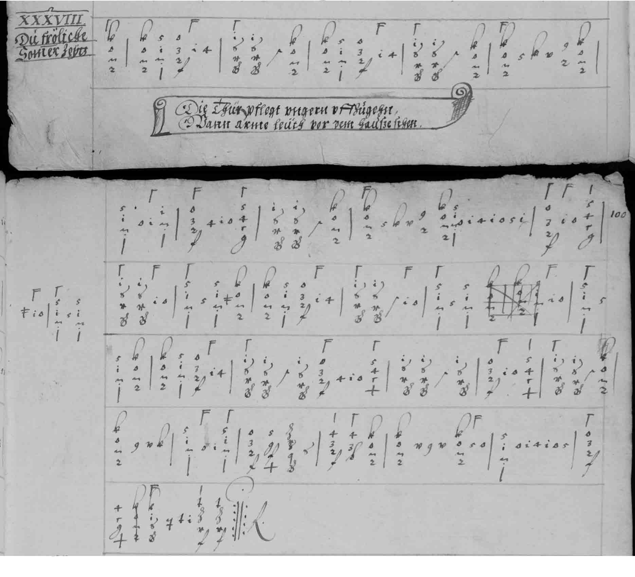

Composite facsimile of H12a - CH-Bu F.IX.70, pp. 99-100†

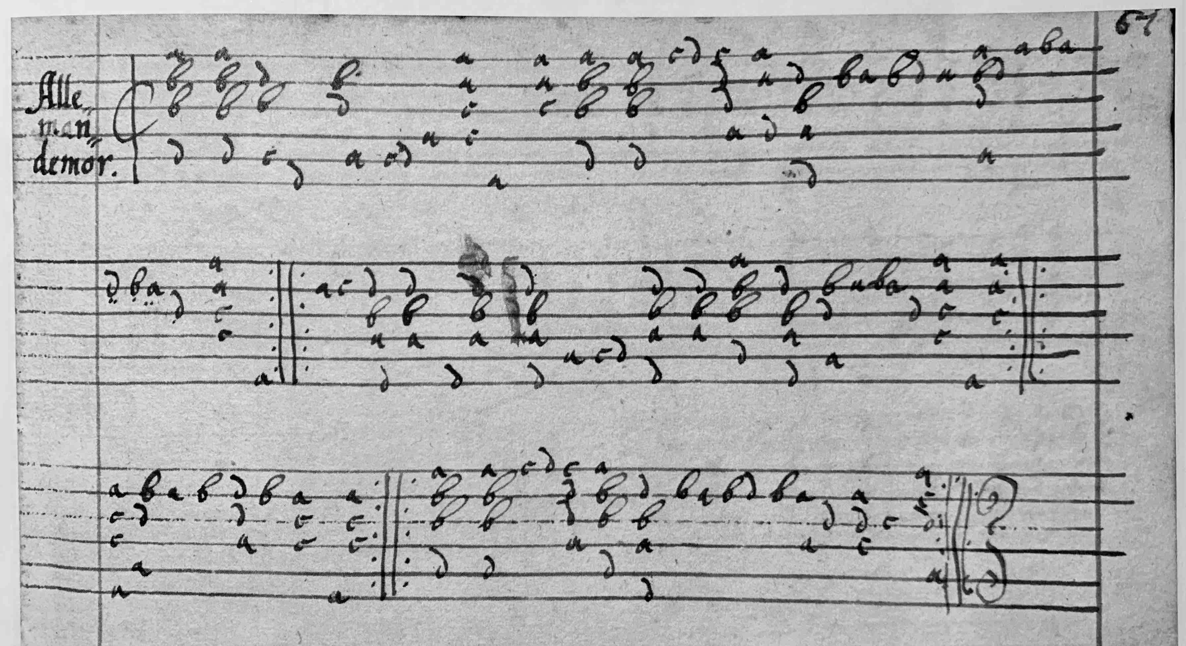

Facsimile of H12i - D-B 40141, f. 67r

1. Keyboard: *D-B 40034 (Loeffelholz), p. ? *Die schena Somer zeytt*; *GB-Lbl Add.29485 (van Soldt), f. 13r *almande de amour*; S-Skma1 (Eysbock), f. 3r *Allamande D'amours*. Instrumental ensemble: *GB-Lbl Roy App 74 (Lumley *c.*1548), f. 44r *Allemana d'amor/ Cantus/ Altus/ tenor/ Bassus*; Phalèse & Bellère 1571, f. 10v *Almande damours* = *Phalèse & Bellère 1583, f. 18r *Almande d'Amour*. Different to: D-Dl M 297, p. 147 *Ach Amor Dantz* ~ PL-Kj 40159, f. 17v *Ach Amor*; D-Kl 4° Mus. 108 I, ff. 36v-37r *Amor*; PL-Kj 40153, f. 19r *Galaria d'amor*.
2. H12l, q, r & u have one 6-bar strain in place of the first two strains A2B4 in other sources, but double bar lines have been added to create A2 and B4 strains editorially for consistency with the other settings for comparison.
3. For example Arthur Ness and John M. Ward *The Königsberg Manuscript A facsimile* (Columbus, Editions Orphée 1989), p. 19 lists H12app 2 as a cognate for H12b,e,h,i,k,m; Ralf Jarchow *Johannes Nauclerus Lautenbuch facsimile* (Glinde, Jarchow Verlag 2010), p. 36 lists H12i as a cognate for H12app 2 & 3; the Thysius Lute Book facsimile edition (Leiden and Utrecht, Nederlandse Luitvereniging 2009) lists H12app 3 as a cognate for H12k; the catalogues published by Christian Meyer listed H12app 4a as a cognate for H12j and H12app 7 as a cognate for H12c; the database of music for lute instruments of Peter Steur and Markus Lutz (https://mss.slweiss.de) ConcR764 lists H12app 1 & 3 as concordances for H12f; Hudson noted that H12app 6 was similar to the settings of *Die schena Somer zeytt* he listed (* in my worklist).
4. Thank you to Peter Király for a facsimile copy.
5. Thank you to Peter Forrester for a facsimle copy.
6. Bars 83/5-91/2 are missing in the original and reconstructed from 67/4-75/2.
7. Jan W.J. Burgers *Joachim van den Hove: Life and Works* (Utrecht, Koninklijke Vereniging voor Nederlandse Musiekgescheidenis 2013).
8. William Chappell, revised H. Ellis Wooldridge *Old English Popular Music* (London, Macmillan 1893/reprinted New York 1961) I, p. 288.
9. George Saintsbury *Minor Poets of the Caroline Period* vol. II (Clarendon 1906), pp. 468-469: <https://archive.org/details/minorpoetsofcaro02sain/page/n3/mode/2up>
10. Daniel Leech-Wilkinson 'The Thynne Lute Book' *The Lute* 33 (1993), pp. 1-11.
11. Luis Torres 'Michael Praetorius and Two English Country Dances' *Folk Music Journal* 2 (1974), pp. 389-395 [although Torres did not make the connection with Rocantins]. The second and third parts of Praetorius' *La Bourree* are settings of the tune *Parsons farewell* in Playford *The Dancing Master* 1651, p. 6 also known in France and elsewhere as 'Bourrée d'Avignon', 19 lute settings edited for *Lute News* 131 (October 2019) and *Lutezine* to *Lute News* 132 (December 2019), although I did not at the time note the cognates in Playford and Praetorius [nor the song to it in Starter 1621, p. 27 'Stil stil een reps' Stemme: *De Nieuwe Laboré*.
12. R3 and R6 superbly recorded by Claire Antonini on the CD *Les Accords Nouveaux: Pierre Ballard 1631* (Claire Antonini, CA-02-2021), tracks 5 & 30.
13. The 'pecard' in the title could be a corruption of bécarre for natural tuning (fdeff), although the tablature is for a lute tuned edeff.
14. Thirty nine transcribed for renaissance lute for the *Lutezine* to *Lute News* 137 (April 2021).
15. Thanks to Denys Stephens for copy a of Daniel Heartz's modern edition from which the barring is taken. See also transcriptions by Richard Civiol and Jason Kortis at: <https://www.scribd.com/document/444729802/Attaingnant-pdf>
16. Related to the chanson 'C'est mon amy' by Janequin, see *Clément Janequin: Chansons polyphoniques*, A.T. Merritt and F. Lesure (Monaco 1965-1971, 2/1983), vi no. 229.
17. Also edited for *114 Early to Intermediate Pieces for Renaissance Lute from a Student’s Lute Book of 1603 and other Manuscripts* (Albury, Lute Society Music Editions 2010), no. 58
18. Numbering from Mariagrazia Carlone ‘The Knights of the Lute: Musical Sources’ *Journal of the Lute Society of America* xxxviii (2005), pp. 1-45 and Tim Crawford *Thirty Pieces for Lute by Laurencini* (The Lute Society Music Editions 1979).
19. I fondly remember this from Julian Bream's recording on LP/CD *The Royal Courts of Europe* (RCA Victor SB6698, 1967) which I bought in 1973.
20. This and B51 & B72 also edited for *Lute News* and *Lutezine* 134 (July 2020).
21. Also edited for *Lute News* 106 (July 2013) with all the music known by Vicenzo Bernia.
22. Also edited for *Lute News* 131 (October 2019).
23. Numbering from Arthur J. Ness (ed.) *The Lute Music of Francesco Canova da Milano (1497-1543)*. Volumes I and II. Tablature and keyboard transciption (Cambridge MA, Harvard University Press, 1970).
24. Jan W.J. Burgers *Three Lute Books from the Dutch Golden Age: Adriaen Valerius Nederlandtsche Gedanck-clank (1626) ~ Leiden BPL 2792 (c.1620) ~ Enkuisizen 1667-1 (1659)* facsimile and modern edition (Lübeck, Tree Edition 2020).
25. Diana Poulton & Basil Lam *The Collected Lute Music of John Dowland* (London, Faber 1974 and revised 1978 and 1981).